Initial Set-up

Please review the following checklist before you begin for the first time. This is a one time set up only:
• Verify that your Internet Browser is set up for “128 Bit Encryption.” See section 11, page 6.

• Install the “Citrix ICA Client” from the C/S Group Citrix web site. See detailed instructions in section 13.

From your Internet browser type in the following URL: https://vo.c-sgroup.com.
• See section 11 (Computer Settings and Shortcuts) for instructions for the following if required:

• Page 1 for instructions on how to set up your computer display settings.

• Page 4 for instructions on how to set up a desktop icon shortcut.

• Page 8 if the “Internet Connection Wizard” starts.

Citrix Metaframe log in screen.
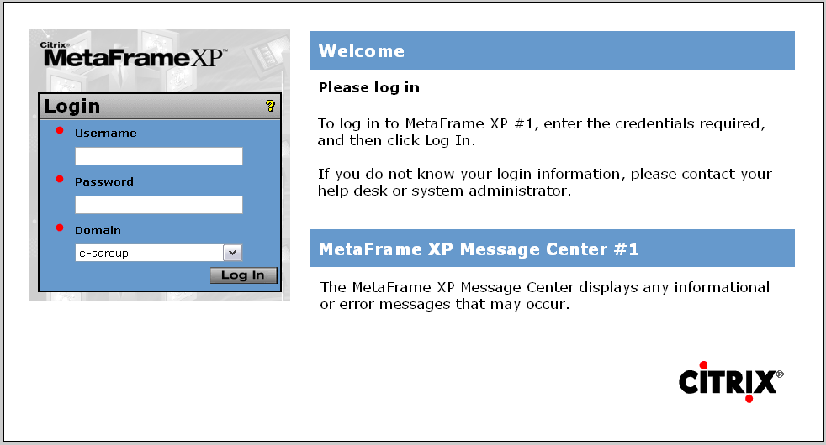
• At the “Username” prompt, enter your user name.
• At the “Domain Password” prompt, enter your password.
• At the “Domain” prompt, enter “c-sgroup”.
• At the “SecurID PASSCODE” prompt, enter your Pin number followed by the six-digit number from the RSA Secure ID FOB*. Note that the system will lock you out if you log in incorrectly three consecutive times. Call 1-800-972-7214 ext. 4024, 5018 or 5019 if this happens.
• Click on the “Send” button at the bottom when complete.
*Note: The number on the FOB changes every 60 seconds.

• Click on the “eRapid Quotes” icon.

• If an error message comes up on the right hand side of the screen asking for the “Citrix ICA Client” please refer to section 11, page 3.

• Select the desired user if you have multiple options or click your user ID button.
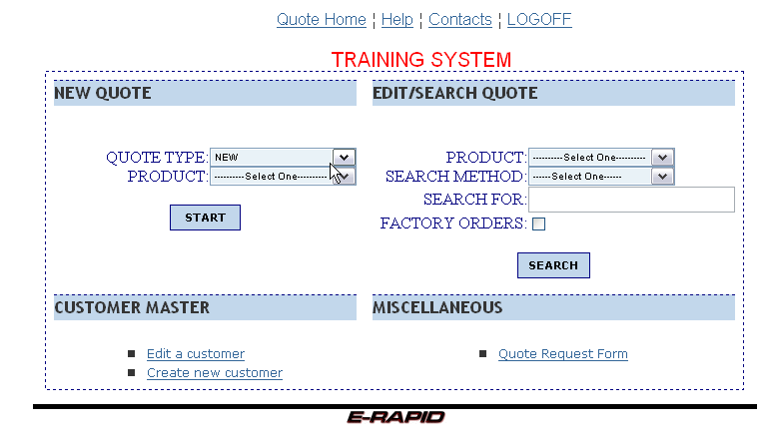
• In the “New Quote” block, click on the down arrow on the Product box.
• Click on the desired product to select.
• Click on the “Start” button to go to the quote header screen.
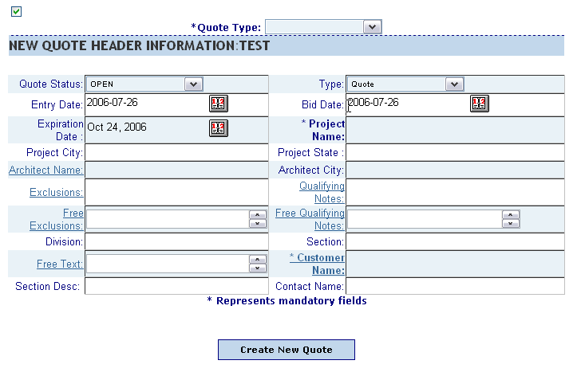
• Note the small check box at the upper left. This is to be used to hide the display of the commission information screens. An example for using this would be, if you were in a customer’s office and did not want him/her to see your commission calculations. When this box is checked the commission information is not displayed. However, commissions will apply correctly whether displayed or not.

• Click on the drop down arrow to the right of the “Quote Type” field, if applicable.
• Select either “Trade (C/S)” or “DecoGard(DG)” as needed.

• Click on the drop down arrow to the right of the Quote Status field.
• This quote status field box would be used to note in the system that a quote is open or closed. This information would be useful for reporting and follow up.

• Click on the drop down arrow to the right of the “Type” field.
• Select Quote, Order or Budget. Order will be used in phase II, disregard it for now. Quote and Budget will be used for reporting purposes.

• Click on the small red and gray calendar icon to the right of the Entry Date.
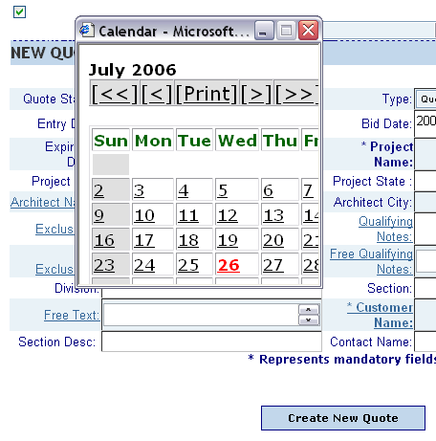
• The entry date defaults to the current date. This date can be changed by going into this calendar and selecting a different date.

• Click on the small red and gray calendar icon to the right of the Bid Date.
• The bid date defaults to the current date. However, it can be changed with the calendar.

• Be sure to close the calendars when complete.

• The Expiration date can also be changed using the calendar. The expiration date defaults 90 days out from the current date.

• At the “Project Name:” prompt, enter the project name. This is a mandatory field. Note that the project name and customer fields are the only required fields for the quote header, unless quote type applies to you.

• Tab to get to the next field.
• Enter the “Project City.”
• Tab over and enter the “Project State.”

• Click on the “Architect Name” label.
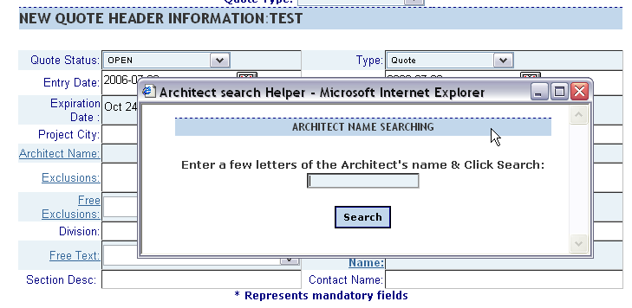

• Enter the first two, three or more letters of the Architect’s name.
• Select the Search button.

• Note that the “%” can be used as a wildcard. Placed in front of the search criteria the search would look for any letters in the middle of the Architect’s name. Without the “%” in front it would look for names starting with the sequence of letters. For example, to search for “Raphael Franco Associates” you could enter “Raph” or “%Franco.”
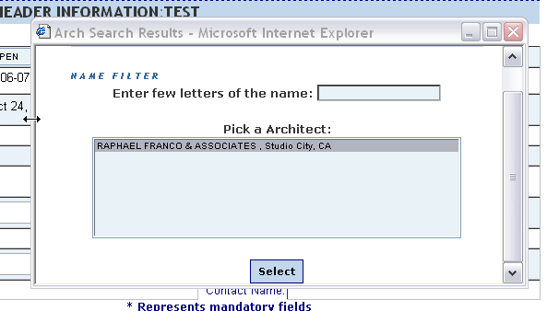

• Highlight the desired Architect by clicking on it.
• Click on the yellow “Select” button to select it and return to the header screen.

• Click on the “Exclusions” label.
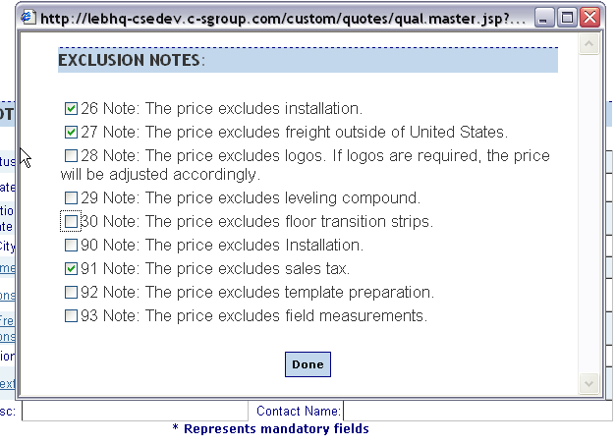

• Click on the box in front of the standard exclusions that you would like to have display on the quote. We suggest that you do not over-use these. Use only if the customer requests them.
• Click on the yellow “Done” button when complete.
• Click on the “Qualifying Notes” label.
• Maximize the pop up screen to see all of the Qualifying Notes.
• Select the qualifying notes that you would like to appear on the printed quote.
• Click on the yellow “Done” button when complete.

• Click on the “Free Exclusions” label.
• Type in any additional exclusion notes that you might want to include.
• Click on the yellow “Done” button when complete.

• Click on the “Free Qualifying Notes” label.
• Click in text box and type in any additional qualifying notes that you might want to include.
• Click on the yellow “Done” button when complete.

• In the “Division” field, enter the specification division. This entry can be any text. For example a typical entry may be simply “12” for division 12. Or enter “12 Flooring” to have both the number and description appear on the quote.

• In the “Section” field, enter the specification section number. This entry can be any text. For example, a typical entry may be simply “12692” or as noted above, text can be added.

• Click on the “Free Text” label.
• Enter free text as required.
• Click on the yellow “Done” button when complete.

• Click on the “Customer Name” label.
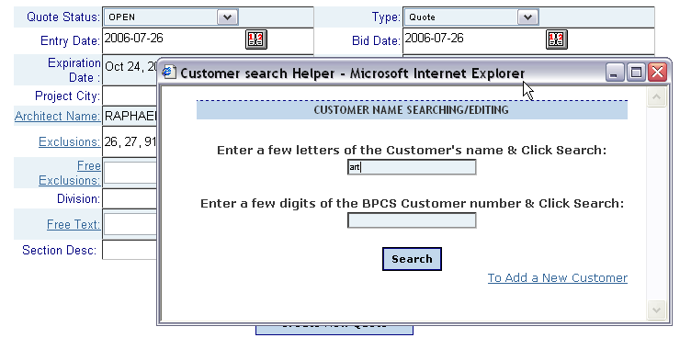

• Click in the open box and type in the first few letters of the customer’s name; press the “Search” button.
• Initially the customer database will be blank. Each representative will enter customers over time. This customer list will only be available to the rep that entered it.
Assuming that there are customers existing:
• Highlight to select the desired Customer by clicking on it.
• Click on the “Select” button to select it and return to the header screen. Verify the correct city is reflected, if not create a new entry with the correct address.

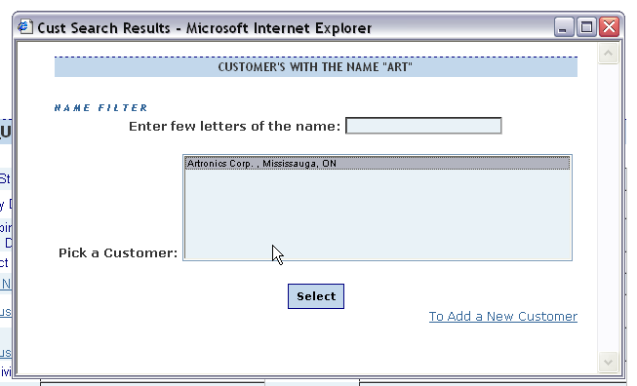

• To enter a customer not in the database click on the blue “To Add a New Customer” text on the lower right of the screen.

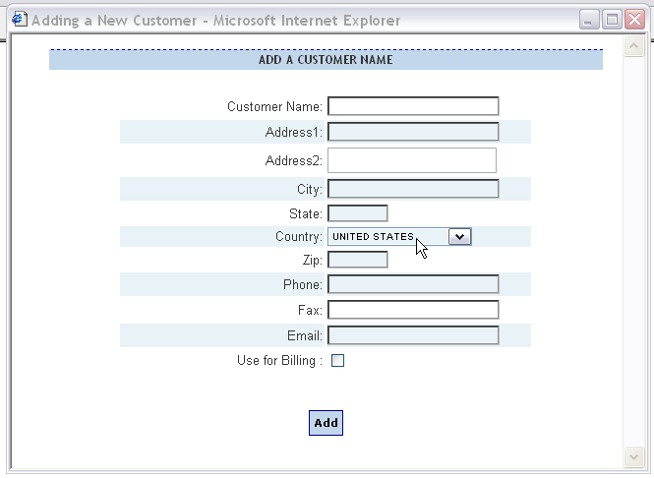

• Fill in the fields as required. Then click on the yellow “Add” button to add this customer to your quote and to your (representative) database.

• Note that customers added to your database are only seen and accessed by you.

• When all entries are complete click on the “Create New Quote” button to go to the line item list.

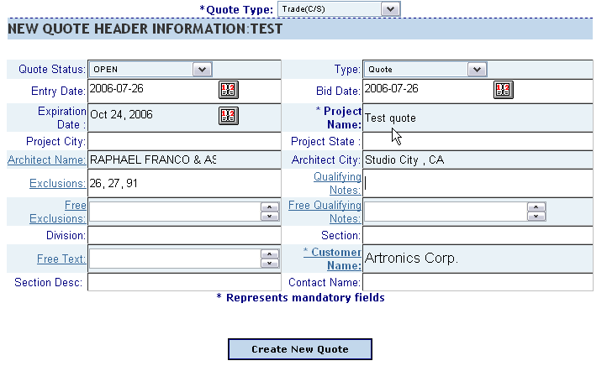

End section.

See Configurator – Typical Pedimat Configuration (section 2) to Continue.

